

**PROJECT DELIVERABLE 3**

**GROUP MEMBERS:**

|  |  |
| --- | --- |
| **NAME** | **ROLL NUMBER** |
| HAIDER ARSHAD | 20I-2379 |
| SHERAZ TARIQ | 21I-1188 |

**USABILITY SPECIFICATION:**

1. **Startup Screen**

**Usability Principles**

**1. Learnability:**

**1.1** Predictability: Yes

**Reason:** By clicking on the “Get Started” button, the user can easily predict that he/she can access the next page easily.

**1.2** Synthesizability: Yes,

**Reason:** By tapping on a button, the user can easily access the next page by knowing past experience.

**1.3** Familiarity: Yes,

**Reason:** This app is similar to another app which is currently running in use.

**1.4** Generalizability: No

**1.5** Consistency: Yes

**Reason:** By tapping on Get Started up button, user can access the next page, button represents something is next there.

**2. Flexibility:**

**2.1** Dialogue Initiative: No

**2.2** Multi-Threading: No

**2.3** Task Migrate ability: No

**2.4** Substitutability: No

**2.5** Customizability: Yes

Reason: User can set the interface according to his choice.

**3. Robustness:**

**3.1** Responsiveness: Yes.

**Reason:** User perceives the rate of communication from the application.

**3.2** Stability: No

**3.3** Recoverability: No

**3.4** Observability: No

**3.5** Task Conformance: Yes

**Reason:** As this startup interface, application support all of the user task.

1. **Startup Screen**

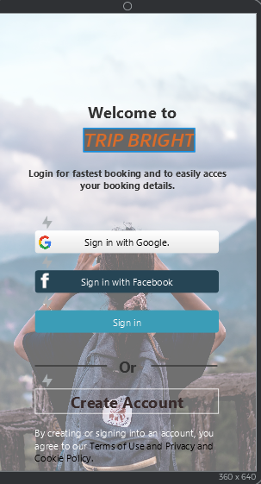

**Usability Principles**

**1. Learnability:**

**1.1** Predictability: Yes

**Reason:** By tapping on Sign up buttons, user can easily predict that he/she can access the next page easily.

**1.2** Synthesizability: Yes

**Reason:** By tapping on button, user can easily access the next page by knowing past experience.

**1.3** Familiarity: Yes

**Reason:** This app is similar to other app which are currently running in use, buttons are also designed on Standard-Based.

**1.4** Generalizability: No

**1.5** Consistency: Yes

**Reason:** By tapping on buttons, user can access the home page, button represents something is next there.

**2. Flexibility:**

**2.1** Dialogue Initiative: No

**2.2** Multi-Threading: No

* 1. Task Migrate ability: Yes

**Reason**: System responsibility to check the data entered by the user and suggest accordingly.

**2.4** Substitutability: No

**2.5** Customizability: No

**3. Robustness:**

**3.1** Responsiveness: Yes

**Reason:** User perceives the rate of communication from the application.

**3.2** Stability: No

**3.3** Recoverability: No

**3.4** Observability: No

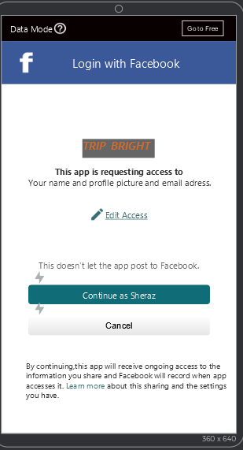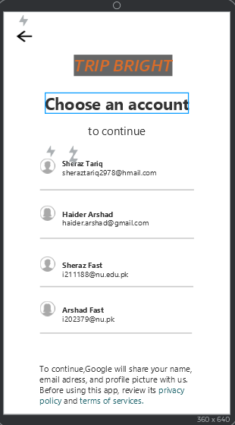**3.5** Task Conformance: Yes**, Reason:** As this All-Sign ups interface, application support all of the user task.

**Facebook/Google Sign up**

**2.1 2.2**

**Usability Principles**

**1. Learnability:**

**1.1** Predictability: Yes

**Reason:** By tapping on sheraz buttons, user can easily predict that he/she can access the next page easily.

**1.2** Synthesizability: Yes

**Reason:** By tapping on button, user can easily access the next page by knowing past experience.

**1.3** Familiarity: Yes

**Reason:** This app is similar to other app which are currently running in use, buttons are also designed on Standard-Based.

**1.4** Generalizability: No

**1.5** Consistency: Yes

**Reason:** By tapping on buttons, user can access the home page, button represents something is next there.

**2. Flexibility:**

**2.1** Dialogue Initiative: No, although privacy policies are mentioned down there.

* 1. Multi-Threading: No
  2. Task Migrate ability: Yes

Reason: System takes the user to the next screen when the data entered is authentic.

**2.4** Substitutability: No

**2.5** Customizability: No

**3. Robustness:**

**3.1** Responsiveness: Yes

**Reason:** User perceives the rate of communication from the application.

**3.2** Stability: No

**3.3** Recoverability: Yes.

**Reason:** By tapping back button or cancel button, user can go back.

**3.4** Observability: No

**3.5** Task Conformance: Yes

**Reason:** As this All-Sign ups interface, application support all of the user task.

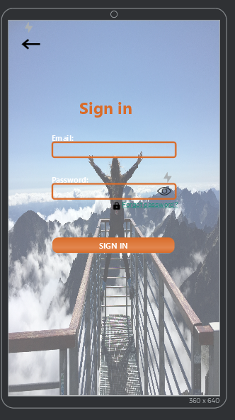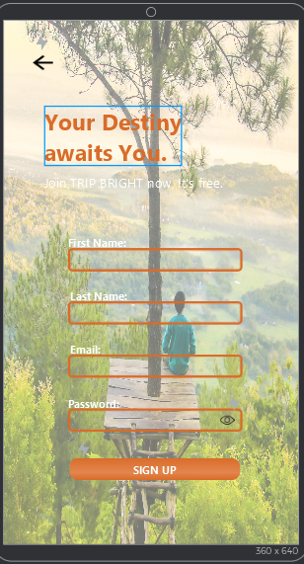

**Sign up/Sign in**

**2.3 2.4**

**Usability Principles**

**1. Learnability:**

**1.1** Predictability: Yes

**Reason:** By tapping on Sign in button, user can easily predict that he/she can access the next page easily.

**1.2** Synthesizability: Yes, **Reason:** By tapping on button, user can easily access the next page by knowing past experience.

**1.3** Familiarity: Yes

**Reason:** This app is similar to other app which are currently running in use, buttons are also designed on Standard-Based.

**1.4** Generalizability: No

**1.5** Consistency: Yes, **Reason:** By tapping on buttons, user can access the home page, button represents something is next there.

**2. Flexibility:**

* 1. Dialogue Initiative: No

**2.2** Multi-Threading: No

**2.3** Task Migrate ability: No

**2.4** Substitutability: Yes, **Reason:** Allowing equivalent values of an input and output to be substitute for each other

**2.5** Customizability: No

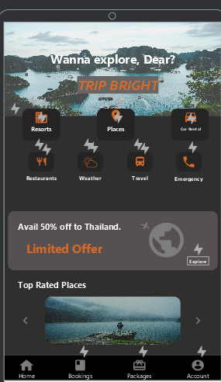**3. Robustness:**

**3.1** Responsiveness: Yes, **Reason:** User perceives the rate of communication from the application.

**3.2** Stability: Yes, **Reason:** If user enters a wrong password, he can recover it.

**3.3** Recoverability: Yes. **Reason:** By tapping back button or cancel button, user can go back.

**3.4** Observability: No

**3.5** Task Conformance: Yes**, Reason:** As this All-Sign ups interface, application support all of the user task.

**Forgot password Interface:**

**2.3.1 2.3.1.1**

These interfaces are also designed on usability principles i.e. if user tap on submit button, confirmation message will be appeared and user can also go back by tapping top back button and ok to confirmation message.

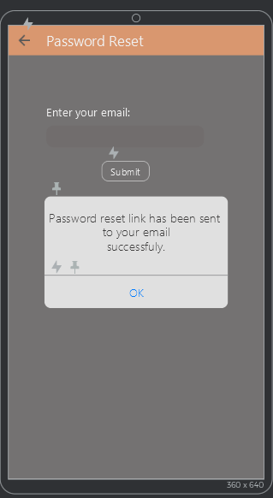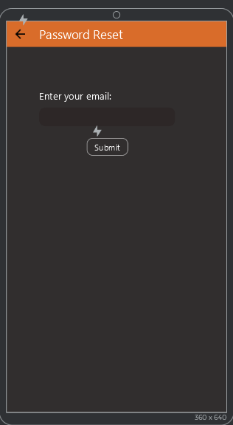

1. **Home Screen**

**Usability Principles**

**1. Learnability:**

**1.1** Predictability: Yes

**Reason:** By tapping on button, user can easily predict that he/she can access the next page easily.

**1.2** Synthesizability: Yes, **Reason:** By tapping on button, user can easily access the next page by knowing past experience.

**1.3** Familiarity: Yes

**Reason:** This app is similar to other app which are currently running in use, buttons are also designed on Standard-Based.

**1.4** Generalizability: Yes, **Reason:** Icons are helping in understanding feature.

**1.5** Consistency: Yes, **Reason:** By tapping on buttons, user can access the next page, button represents something is next there.

**2. Flexibility:**

* 1. Dialogue Initiative: No.

**2.2** Multi-Threading: No

**2.3** Task Migrate ability: No

**2.4** Substitutability: No

**2.5** Customizability: No

**3. Robustness:**

**3.1** Responsiveness: Yes, **Reason:** User perceives the rate of communication from the application.

**3.2** Stability: No.

**3.3** Recoverability: Yes. **Reason:** By tapping account button or cancel button, user can go back from logout.

**3.4** Task Conformance: Yes**, Reason:** As this home interface, application support all of the user task.

**Resorts**

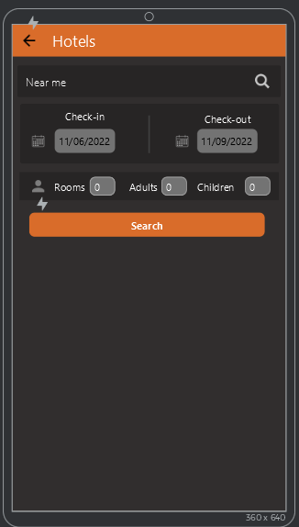**3.1 3.1.1**

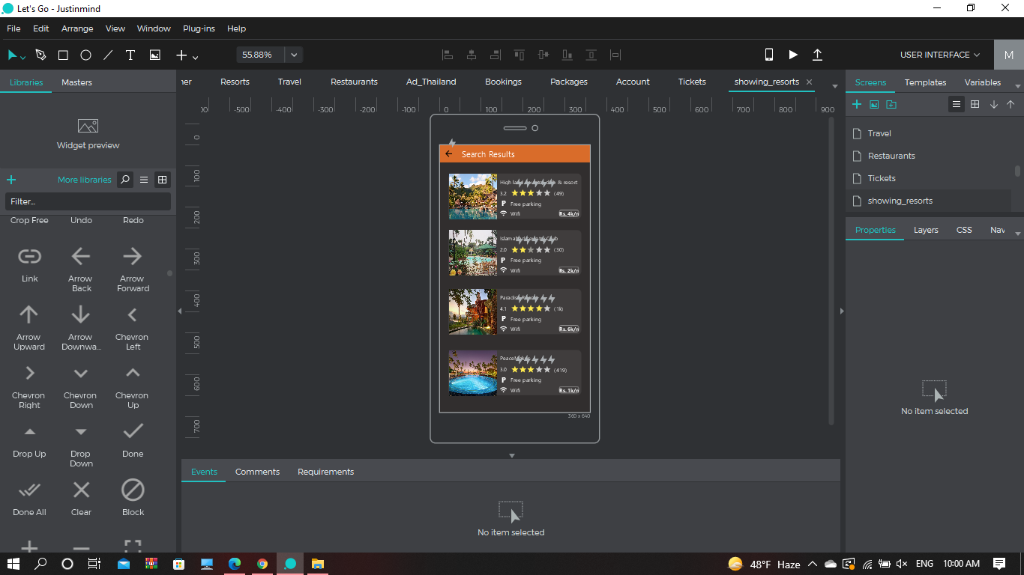

**Usability Principles**

**1. Learnability:**

**1.1** Predictability: Yes

**Reason:** By tapping on button, user can easily predict that he/she can access the next page easily.

**1.2** Synthesizability: Yes, **Reason:** By tapping on button, user can easily access the next page by knowing past experience.

**1.3** Familiarity: Yes

**Reason:** This app is similar to other app which are currently running in use, buttons are also designed on Standard-Based.

**1.4** Generalizability: No

**1.5** Consistency: Yes, **Reason:** By tapping on buttons, user can access the next page, button represents something is next there.

**2. Flexibility:**

* 1. Dialogue Initiative: No.

**2.2** Multi-Threading: No

**2.3** Task Migrate ability: No

**2.4** Substitutability: No

**2.5** Customizability: No

**3. Robustness:**

**3.1** Responsiveness: Yes, **Reason:** User perceives the rate of communication from the application.

**3.2** Stability: No.

**3.3** Recoverability: Yes. **Reason:** By tapping top back button, user can go back.

**3.4** Task Conformance: Yes**, Reason:** As this Bookings interface, application support all of the user task.

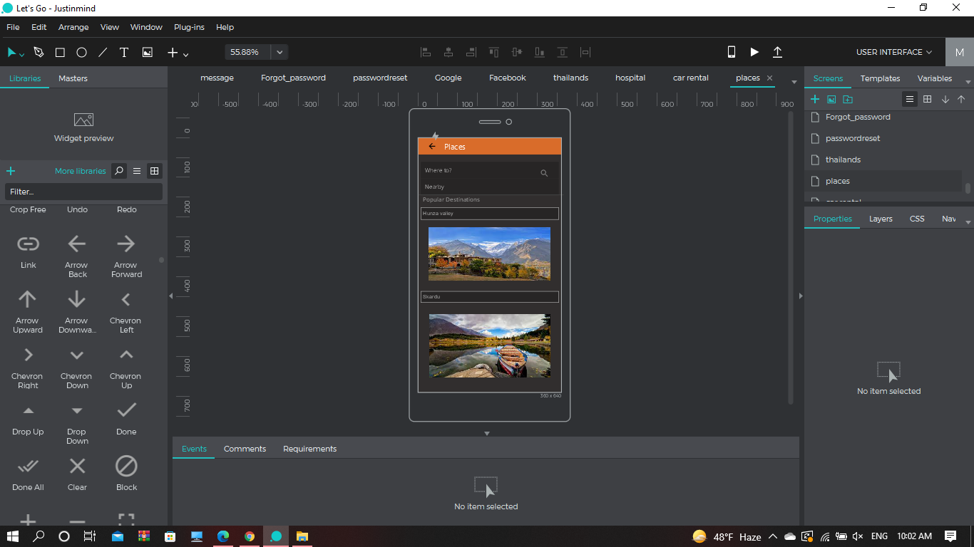**3.2 Places**

**Usability Principles**

**1. Learnability:**

**1.1** Predictability: Yes

**Reason:** By tapping on button, user can easily predict that he/she can access the next page easily.

**1.2** Synthesizability: Yes, **Reason:** By tapping on button, user can easily access the next page by knowing past experience.

**1.3** Familiarity: Yes

**Reason:** This app is similar to other app which are currently running in use, buttons are also designed on Standard-Based.

**1.4** Generalizability: No

**1.5** Consistency: Yes, **Reason:** By tapping on buttons, user can access the next page, button represents something is next there.

**2. Flexibility:**

* 1. Dialogue Initiative: No.

**2.2** Multi-Threading: No

**2.3** Task Migrate ability: No

**2.4** Substitutability: No

**2.5** Customizability: No

**3. Robustness:**

**3.1** Responsiveness: Yes, **Reason:** User perceives the rate of communication from the application.

**3.2** Stability: No.

**3.3** Recoverability: Yes. **Reason:** By tapping top back button, user can go back.

**3.4** Task Conformance: Yes**, Reason:** As this places interface, application support all of the user task.

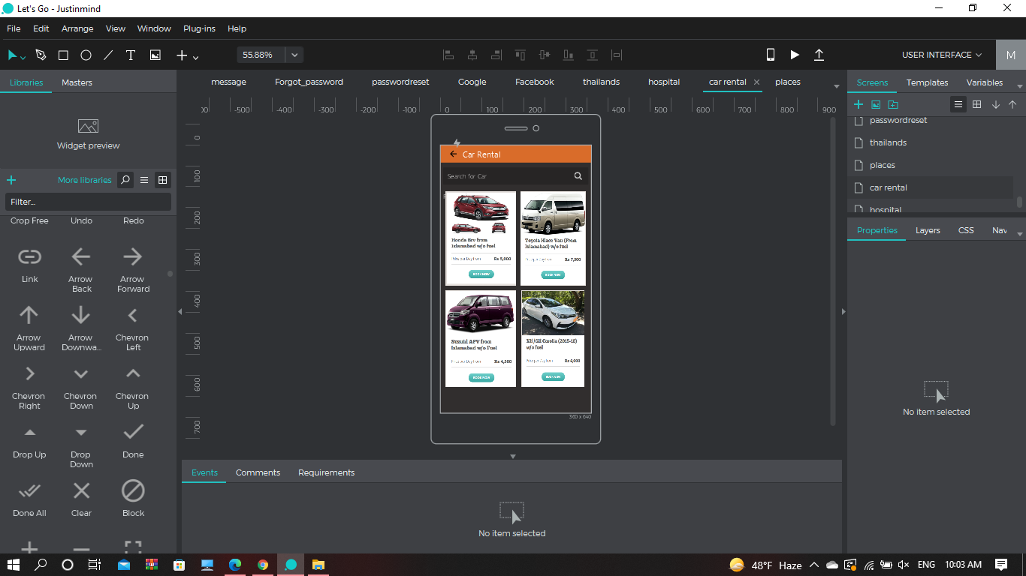**3.3 Car Rental**

**Usability Principles**

**1. Learnability:**

**1.1** Predictability: Yes

**Reason:** By tapping on button, user can easily predict that he/she can access the next page easily.

**1.2** Synthesizability: Yes, **Reason:** By tapping on button, user can easily access the next page by knowing past experience.

**1.3** Familiarity: Yes

**Reason:** This app is similar to other app which are currently running in use, buttons are also designed on Standard-Based.

**1.4** Generalizability: No

**1.5** Consistency: Yes, **Reason:** By tapping on buttons, user can access the next page, button represents something is next there.

**2. Flexibility:**

* 1. Dialogue Initiative: No.

**2.2** Multi-Threading: No

**2.3** Task Migrate ability: No

**2.4** Substitutability: No

**2.5** Customizability: No

**3. Robustness:**

**3.1** Responsiveness: Yes, **Reason:** User perceives the rate of communication from the application.

**3.2** Stability: No.

**3.3** Recoverability: Yes. **Reason:** By tapping top back button, user can go back.

**3.4** Task Conformance: Yes**, Reason:** As this car-rental interface, application support all of the user task.

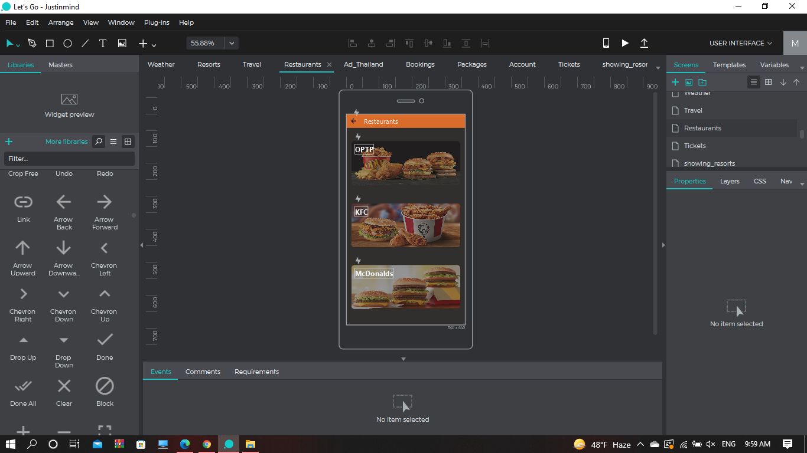**3.4 Restaurants**

**Usability Principles**

**1. Learnability:**

**1.1** Predictability: Yes

**Reason:** By tapping on button, user can easily predict that he/she can access the next page easily.

**1.2** Synthesizability: Yes, **Reason:** By tapping on button, user can easily access the next page by knowing past experience.

**1.3** Familiarity: Yes

**Reason:** This app is similar to other app which are currently running in use, buttons are also designed on Standard-Based.

**1.4** Generalizability: No

**1.5** Consistency: Yes, **Reason:** By tapping on buttons, user can access the next page, button represents something is next there.

**2. Flexibility:**

* 1. Dialogue Initiative: No.

**2.2** Multi-Threading: No

**2.3** Task Migrate ability: No

**2.4** Substitutability: No

**2.5** Customizability: No

**3. Robustness:**

**3.1** Responsiveness: Yes, **Reason:** User perceives the rate of communication from the application.

**3.2** Stability: No.

**3.3** Recoverability: Yes. **Reason:** By tapping top back button, user can go back.

**3.4** Task Conformance: Yes**, Reason:** As this restaurants interface, application support all of the user task.

**3.5 Weather**

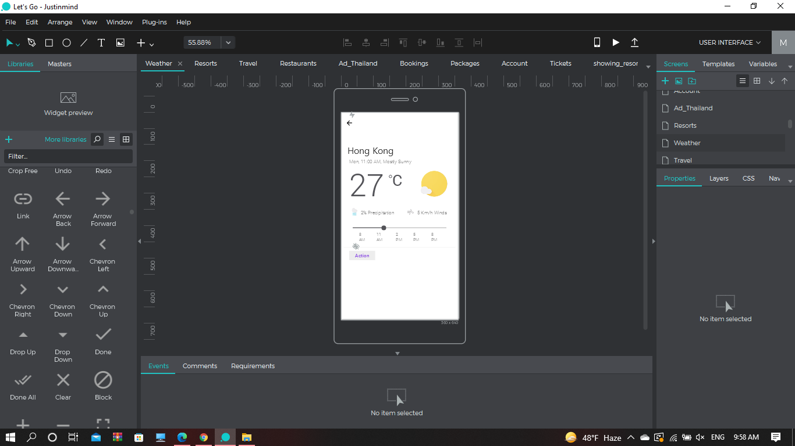**Usability Principles**

**1. Learnability:**

**1.1** Predictability: Yes

**Reason:** By tapping on button, user can easily predict that he/she can access the next page easily.

**1.2** Synthesizability: Yes, **Reason:** By tapping on button, user can easily access the next page by knowing past experience.

**1.3** Familiarity: Yes

**Reason:** This app is similar to other app which are currently running in use, buttons are also designed on Standard-Based.

**1.4** Generalizability: No

**1.5** Consistency: Yes, **Reason:** By tapping on buttons, user can access the next page, button represents something is next there.

**2. Flexibility:**

* 1. Dialogue Initiative: No.

**2.2** Multi-Threading: No

**2.3** Task Migrate ability: No

**2.4** Substitutability: No

**2.5** Customizability: No

**3. Robustness:**

**3.1** Responsiveness: Yes, **Reason:** User perceives the rate of communication from the application.

**3.2** Stability: No.

**3.3** Recoverability: Yes. **Reason:** By tapping top back button, user can go back.

**3.4** Task Conformance: Yes**, Reason:** As this weather interface, application support all of the user task.

**3.6 Travel**

**3.6.1**

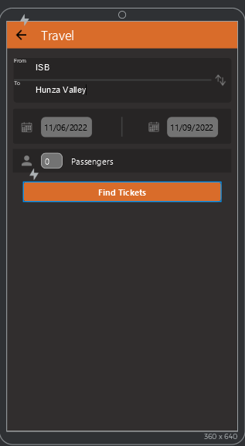

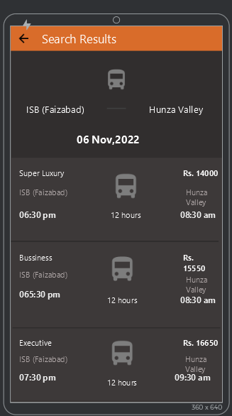

**Usability Principles**

**1. Learnability:**

**1.1** Predictability: Yes

**Reason:** By tapping on button, user can easily predict that he/she can access the next page easily.

**1.2** Synthesizability: Yes, **Reason:** By tapping on button, user can easily access the next page by knowing past experience.

**1.3** Familiarity: Yes

**Reason:** This app is similar to other app which are currently running in use, buttons are also designed on Standard-Based.

**1.4** Generalizability: No

**1.5** Consistency: Yes, **Reason:** By tapping on buttons, user can access the next page, button represents something is next there.

**2. Flexibility:**

* 1. Dialogue Initiative: No.

**2.2** Multi-Threading: No

**2.3** Task Migrate ability: No

**2.4** Substitutability: No

**2.5** Customizability: No

**3. Robustness:**

**3.1** Responsiveness: Yes, **Reason:** User perceives the rate of communication from the application.

**3.2** Stability: No.

**3.3** Recoverability: Yes. **Reason:** By tapping top back button, user can go back.

**3.4** Task Conformance: Yes**, Reason:** As this travel interface, application support all of the user task.

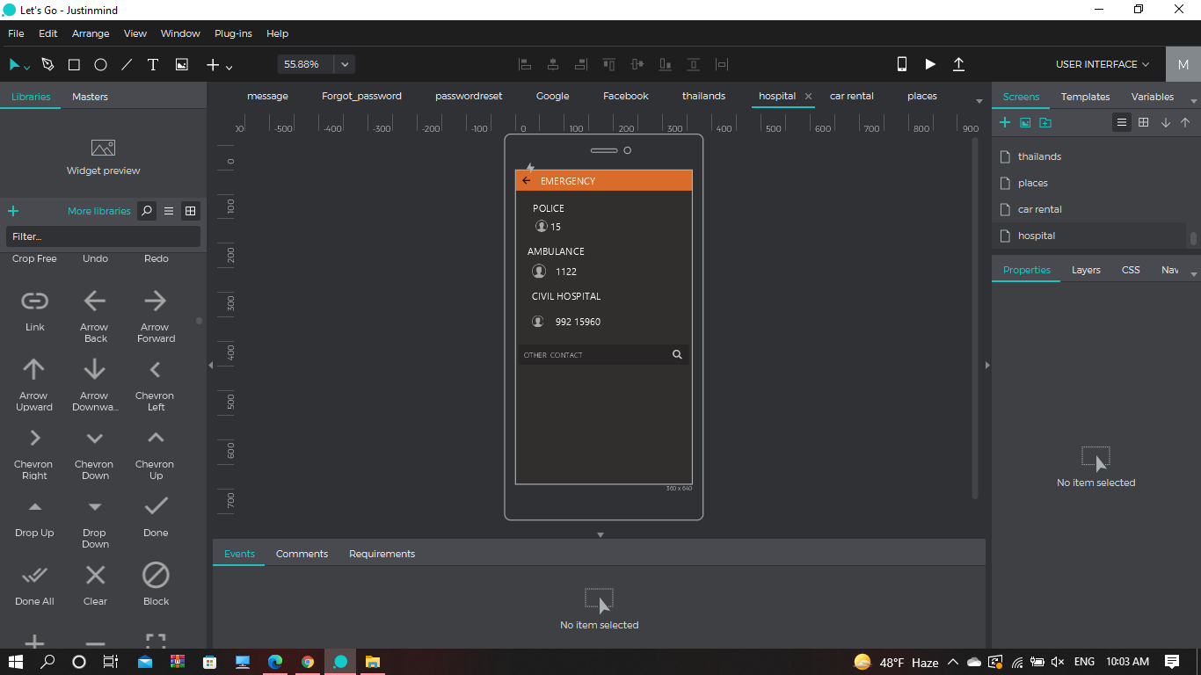**3.7 Emergency**

**Usability Principles**

**1. Learnability:**

**1.1** Predictability: Yes

**Reason:** By tapping on button, user can easily predict that he/she can access the next page easily.

**1.2** Synthesizability: Yes, **Reason:** By tapping on button, user can easily access the next page by knowing past experience.

**1.3** Familiarity: Yes

**Reason:** This app is similar to other app which are currently running in use, buttons are also designed on Standard-Based.

**1.4** Generalizability: No

**1.5** Consistency: Yes, **Reason:** By tapping on buttons, user can access the next page, button represents something is next there.

**2. Flexibility:**

* 1. Dialogue Initiative: No.

**2.2** Multi-Threading: No

**2.3** Task Migrate ability: No

**2.4** Substitutability: No

**2.5** Customizability: No

**3. Robustness:**

**3.1** Responsiveness: Yes, **Reason:** User perceives the rate of communication from the application.

**3.2** Stability: No.

**3.3** Recoverability: Yes. **Reason:** By tapping top back button, user can go back.

**3.4** Task Conformance: Yes**, Reason:** As this emergency interface, application support all of the user task.

**3.8 Thailand Discount**

**3.8.1**

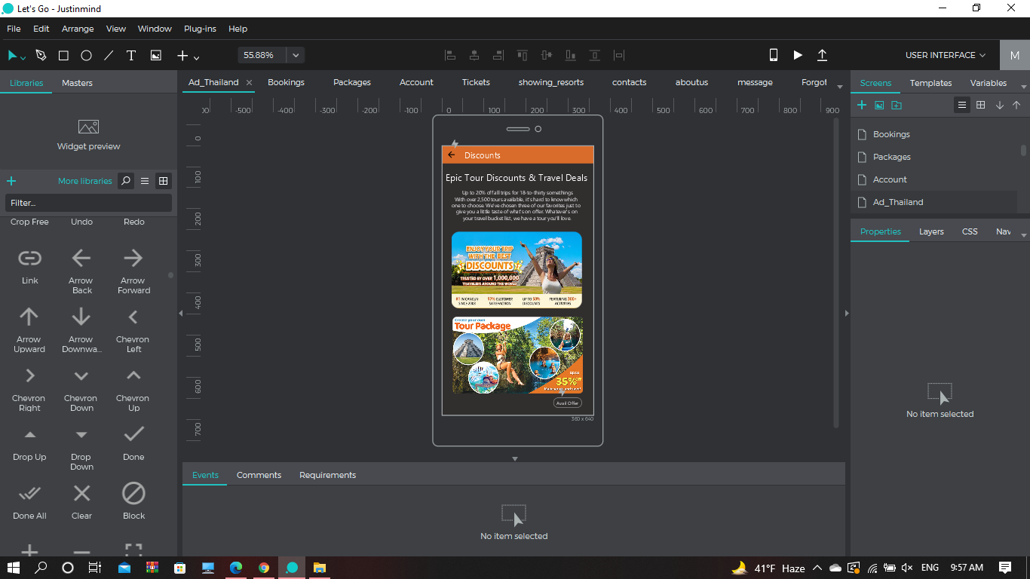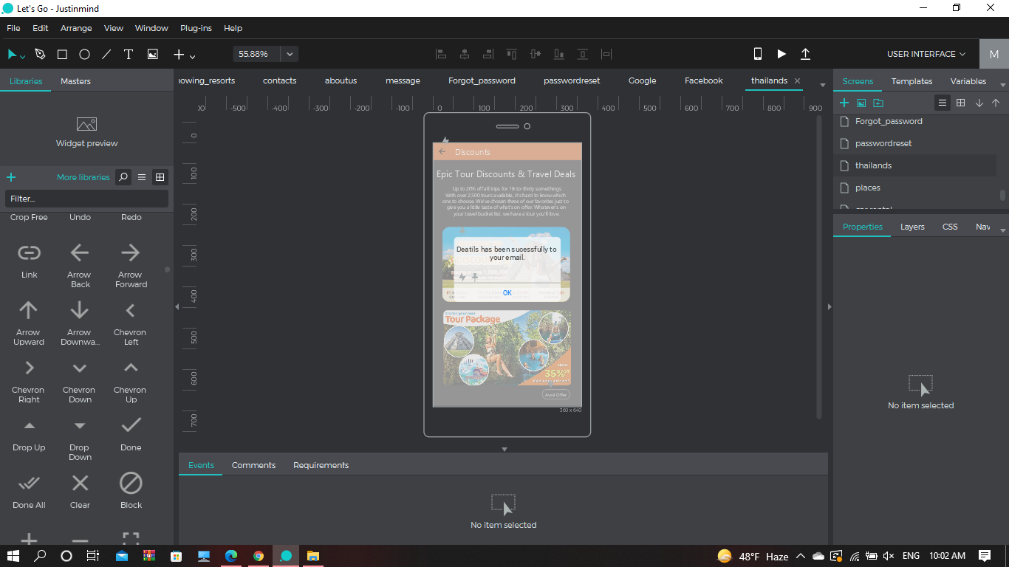

**Usability Principles**

**1. Learnability:**

**1.1** Predictability: Yes

**Reason:** By tapping on button, user can easily predict that he/she can access the next page easily.

**1.2** Synthesizability: Yes

**Reason:** By tapping on button, user can easily access the next page by knowing past experience.

**1.3** Familiarity: Yes

**Reason:** This app is similar to other app which are currently running in use, buttons are also designed on Standard-Based.

**1.4** Generalizability: No

**1.5** Consistency: Yes

**Reason:** By tapping on buttons, user can access the next page, button represents something is next there.

**2. Flexibility:**

* 1. Dialogue Initiative: No.

**2.2** Multi-Threading: No

**2.3** Task Migrate ability: No

**2.4** Substitutability: No

**2.5** Customizability: No

**3. Robustness:**

**3.1** Responsiveness: Yes

**Reason:** User perceives the rate of communication from the application.

**3.2** Stability: No.

**3.3** Recoverability: Yes.

**Reason:** By tapping top back button, user can go back.

**3.4** Task Conformance: Yes

**Reason:** As this discount interface, application support all of the user task.

**3.9 Bookings**

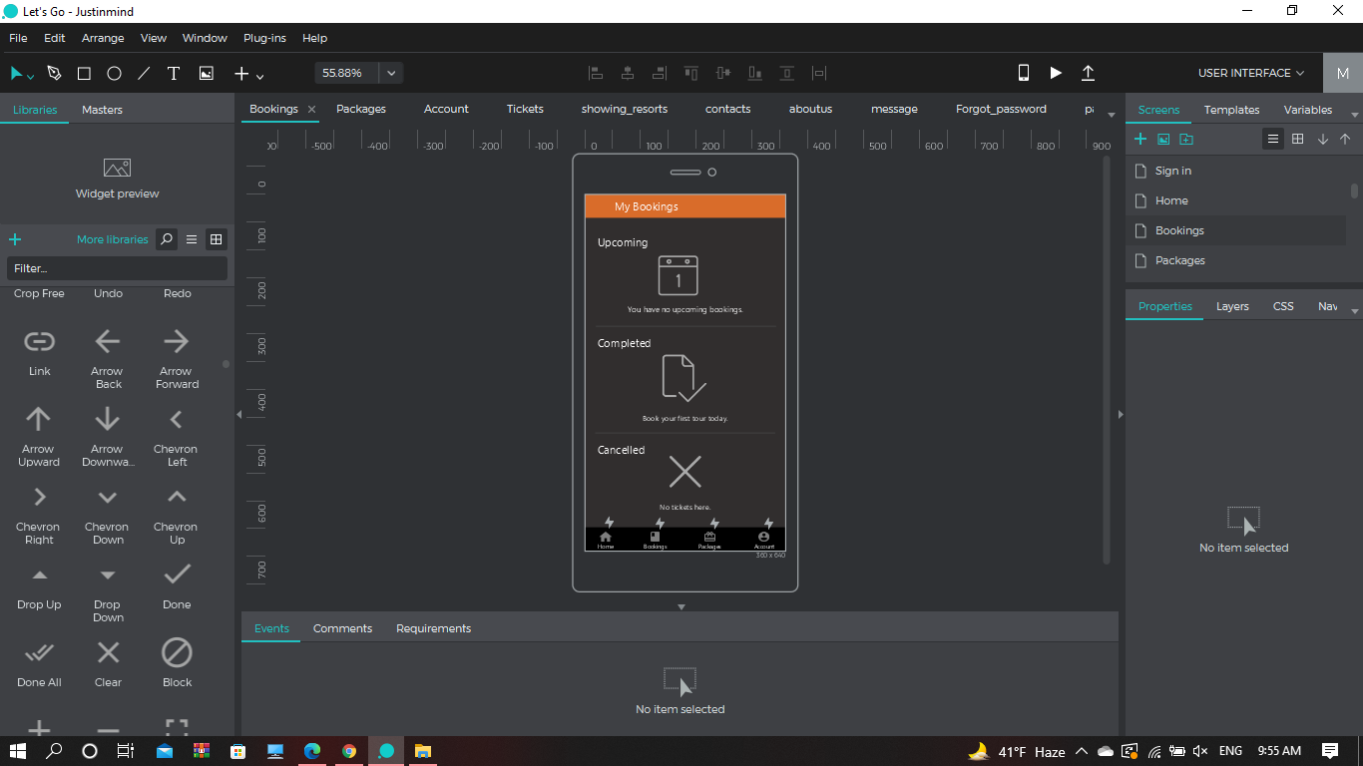

**Usability Principles**

**1. Learnability:**

**1.1** Predictability: Yes

**Reason:** By tapping on button, user can easily predict that he/she can access the next page easily.

**1.2** Synthesizability: Yes, **Reason:** By tapping on button, user can easily access the next page by knowing past experience.

**1.3** Familiarity: Yes

**Reason:** This app is similar to other app which are currently running in use, buttons are also designed on Standard-Based.

**1.4** Generalizability: No

**1.5** Consistency: Yes, **Reason:** By tapping on buttons, user can access the next page, button represents something is next there.

**2. Flexibility:**

* 1. Dialogue Initiative: No.

**2.2** Multi-Threading: No

**2.3** Task Migrate ability: No

**2.4** Substitutability: No

**2.5** Customizability: No

**3. Robustness:**

**3.1** Responsiveness: Yes, **Reason:** User perceives the rate of communication from the application.

**3.2** Stability: No.

**3.3** Recoverability: Yes. **Reason:** By tapping top back button, user can go back.

**3.4** Task Conformance: Yes**, Reason:** As this bookings interface, application support all of the user task.

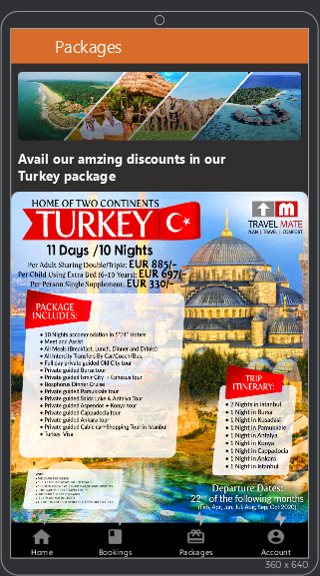**3.10 Packages**

**Usability Principles**

**1. Learnability:**

**1.1** Predictability: Yes

**Reason:** By tapping on button, user can easily predict that he/she can access the next page easily.

**1.2** Synthesizability: Yes,

**Reason:** By tapping on button, user can easily access the next page by knowing past experience.

**1.3** Familiarity: Yes

**Reason:** This app is similar to other app which are currently running in use, buttons are also designed on Standard-Based.

**1.4** Generalizability: No

**1.5** Consistency: Yes, **Reason:** By tapping on buttons, user can access the next page, button represents something is next there.

**2. Flexibility:**

* 1. Dialogue Initiative: No.

**2.2** Multi-Threading: No

**2.3** Task Migrate ability: No

**2.4** Substitutability: No

**2.5** Customizability: No

**3. Robustness:**

**3.1** Responsiveness: Yes, **Reason:** User perceives the rate of communication from the application.

**3.2** Stability: No.

**3.3** Recoverability: Yes. **Reason:** By tapping top back button, user can go back.

**3.4** Task Conformance: Yes**, Reason:** As this packages interface, application support all of the user task.

**3.11 Account**

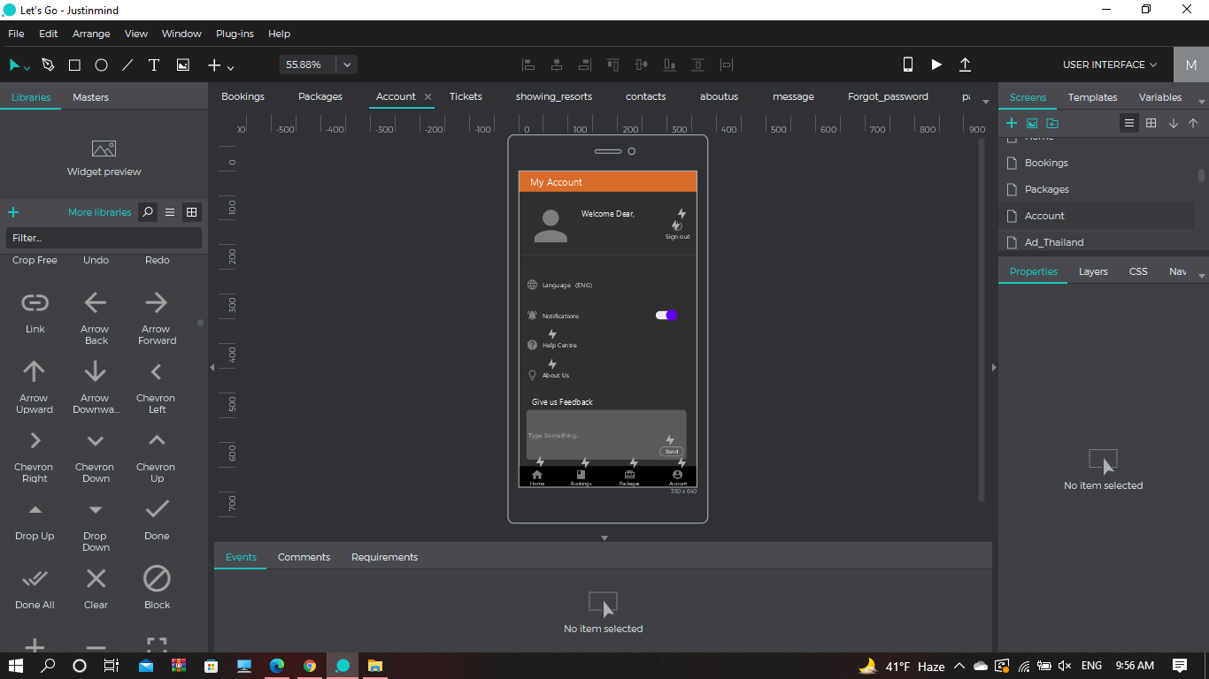 **3.11.1**

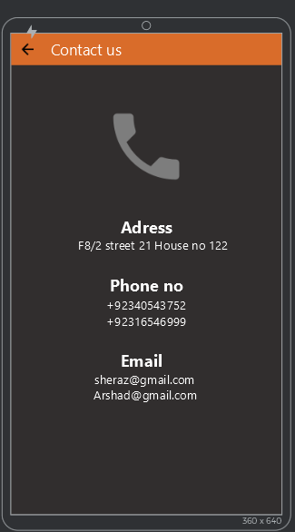

**3.11.2 3.11.3**

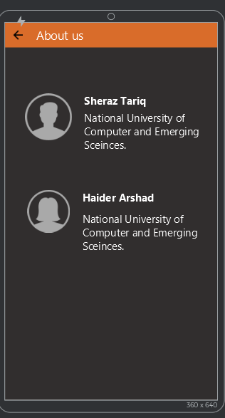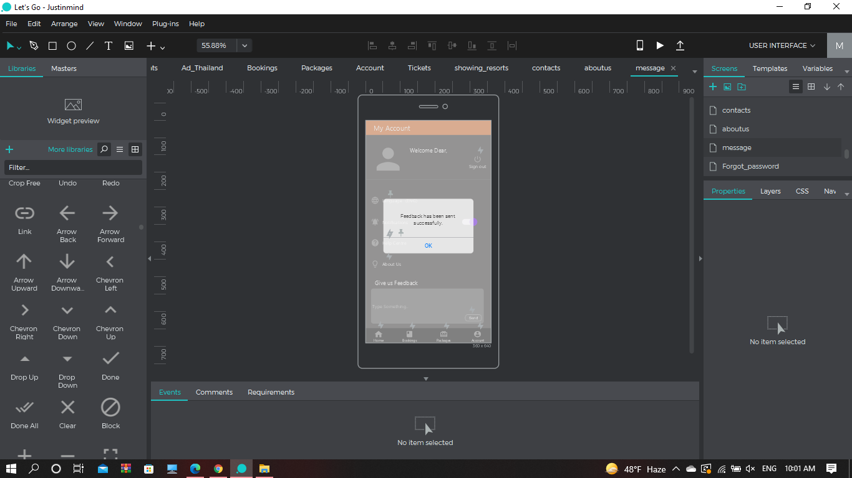

**Usability Principles**

**1. Learnability:**

**1.1** Predictability: Yes

**Reason:** By tapping on button, user can easily predict that he/she can access the next page easily.

**1.2** Synthesizability: Yes

**Reason:** By tapping on button, user can easily access the next page by knowing past experience.

**1.3** Familiarity: Yes

**Reason:** This app is similar to other app which are currently running in use, buttons are also designed on Standard-Based.

**1.4** Generalizability: No

**1.5** Consistency: Yes

**Reason:** By tapping on buttons, user can access the next page, button represents something is next there.

**2. Flexibility:**

* 1. Dialogue Initiative: No.

**2.2** Multi-Threading: No

**2.3** Task Migrate ability: No

**2.4** Substitutability: No

**2.5** Customizability: No

**3. Robustness:**

**3.1** Responsiveness: Yes

**Reason:** User perceives the rate of communication from the application.

**3.2** Stability: No.

**3.3** Recoverability: Yes.

**Reason:** By tapping top back button, user can go back.

**3.4** Task Conformance: Yes

**Reason:** As this Account interface, application support all of the user task.

**Nielson’s Heuristics Analysis:**

1. **Visibility of system status:** No

**Reason:** The application is designed in the standard style and the interface is not that difficult so user will not understand it instead of this, user can use the application without need of notifications in a clean manner.

## Match between system and the real world: Yes

## How: Different real life animation-based icons are used in application, so user can easily understand about features by just seeing it.

## User control and freedom: Yes

## How: Every screen has go-back button and user can also logout from system.

## Consistency and standards: Yes.

## How: All icons, button formats, text styles are designed on industry conventions.

## Error prevention: No

## Reason: There are less chances of error occurrence.

## Recognition rather than recall: Yes

## How: Application is designed in this way, so that 13+ age can use the application and easily perform any function.

## Flexibility and efficiency of use: No

## Reason: Application is already very easy to use, no need of any further shortcuts.

## Aesthetic and minimalist design: Yes

## How: There is an emergency button on home screen which is usually rare on main pages but in tour planner application, it can be useful in emergency.

## Help users recognize, diagnose, and recover from errors: Yes

## How: Messages are showing in plain text, no technical language is used.

## Help and documentation: No

## Reason: Application does not need any manual, user can easily use this application without any help.

**User Testing**:

The Screens were distributed among different people. And the users were asked to navigate the system and provide feedback based on the experience during use. The issue found by the user was on the sign-in with google page. The user can only sign in through the existing account on the device and wasn’t able to add another account.



We resolved the issue by adding an option of “add another account” so that the user can also sign in by adding another account.

